Luke Evans

January 16th, 2021

**Internet Security – Lab 1**

*Sniffing and Spoofing*

**Task 1: Using tools to sniff and spoof packets**

*1.1 Sniffing Packets:*

1.1.A:

The python code for sniffing icmp packets is shown in the screenshot below:

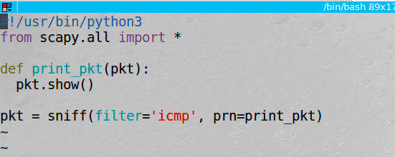

We can run the sniffer program with root privileges and ping another ip from a different terminal tab to capture the icmp packet:

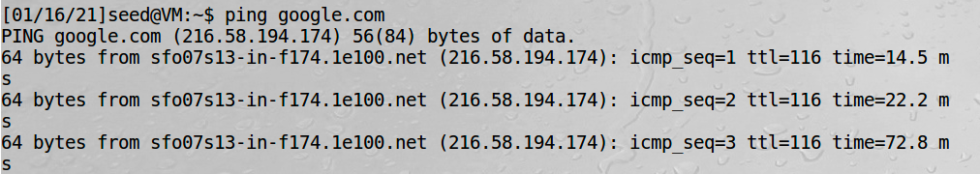

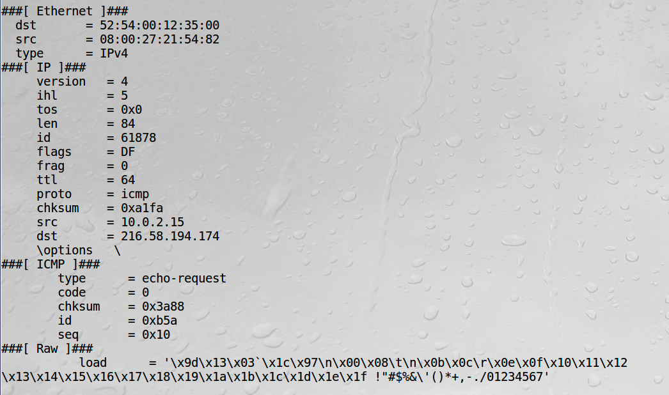

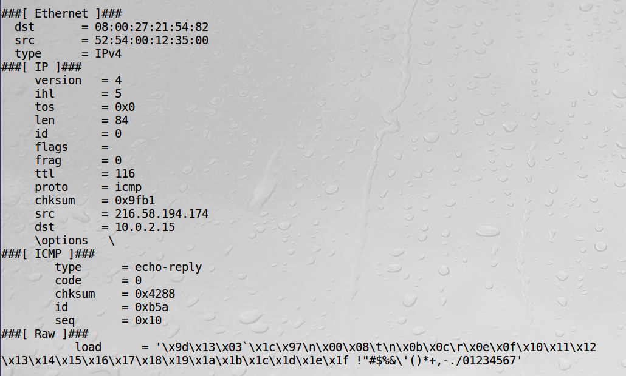

When we attempt to run the program without root privileges, we get the following error:

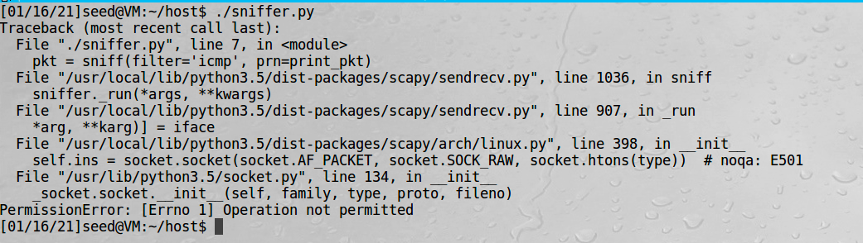

Observations: Our simple sniffer.py program shows how we can use scapy to sniff packets. The program works when running with root privileges, however, it will crash when trying to run as a normal user. The reason the program is unable to run without root privileges is it requires the use of a raw socket and the network interface card must be put in promiscuous mode to sniff all icmp packets on the network. This is not allowed unless funning as root which is why we see the permission error.

1.1.B:

The code for capturing only icmp packets is the same code that was used in section 1.1.A:



If we send a ping request to google.com we see the echo-request and echo-reply:





The code to only sniff tcp packets is shown below. We can use the same code as above but we change the icmp filter to tcp:

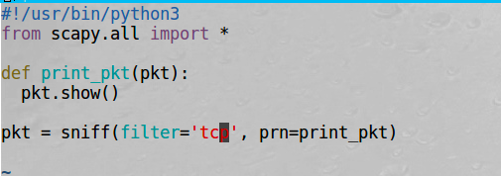

If we then open firefox we can capture the tcp packets being transmitted:

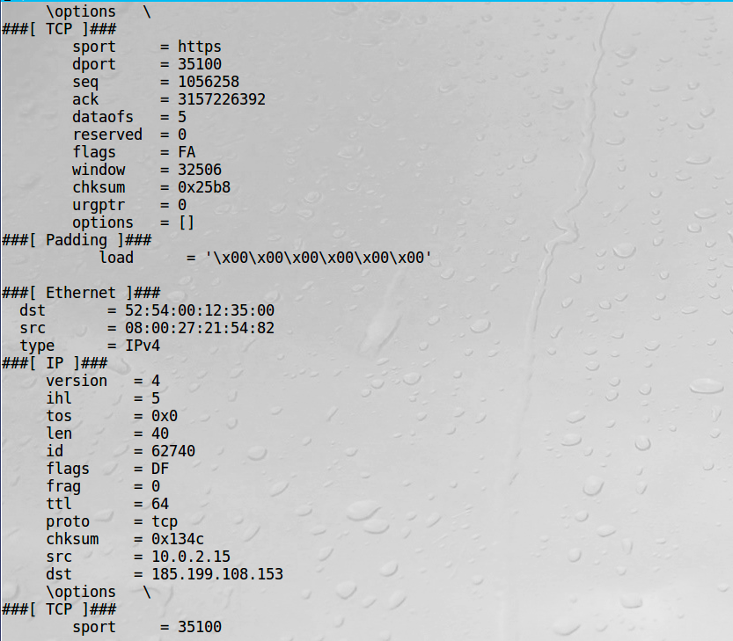

If we only want to capture packets from a specific subnet we can update the filter to use the net keyword with the classless IPv4 address. In our example we will use subnet 192.168.0.0/16 and then ping an ip within the specified subnet to capture the packet. The python code is shown below:

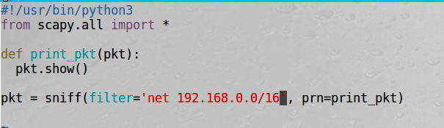

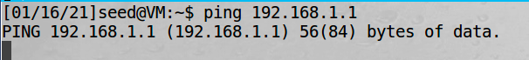

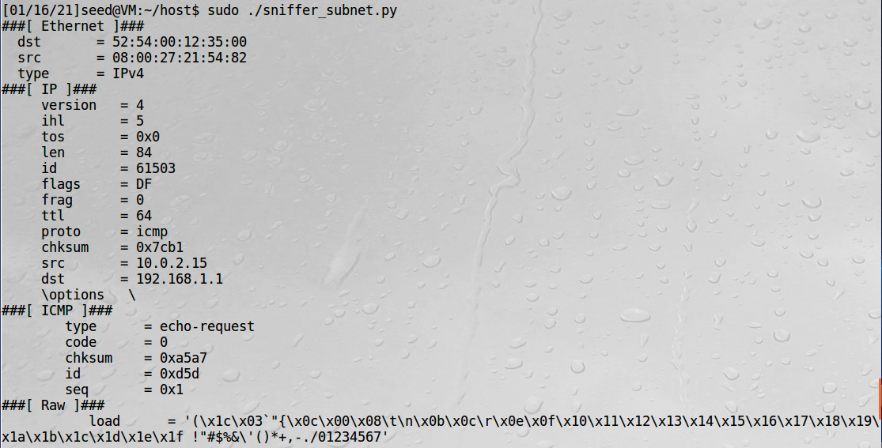

In this case we do not get an echo response because the provided ip address within the specified server is not alive and able to respond.

Observations: The screenshots above show how filters can be applied to sniff packets of a specific type. We first were only interested in ICMP packets, then tcp packets, and finally packets to or from the specified subnet of 192.168.0.0/16.

Explanation: Scapy allows for various filters to easily be applied to our packet sniffer using BPF syntax.

*1.2 Spoofing ICMP Packets:*

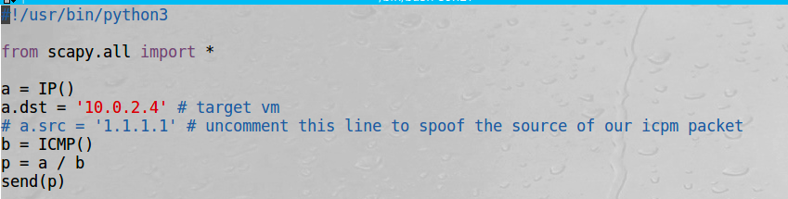

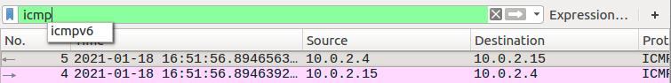

Observation: When we run our script from the VM with ip address 10.0.2.15 and set the destination ip to 10.0.2.4 we can observe this ICMP packet on wireshark. We are currently not spoofing the source address. Since we have a.src commented out above the source of the request is auto populated with our real ip address. The code below we will set our ip to 1.1.1.1.

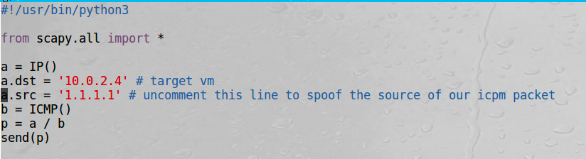

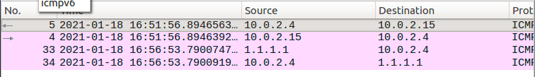

Observation/Explanation: With a.src set in the code to 1.1.1.1 the source IP is spoofed and so the reply is sent back to that IP. We have successfully spoofed our icmp request. Scapy makes this operation trivial.

*1.3 Traceroute:*

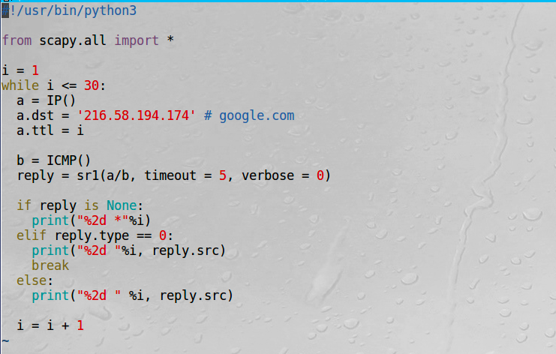

The output from the code above is shown below:

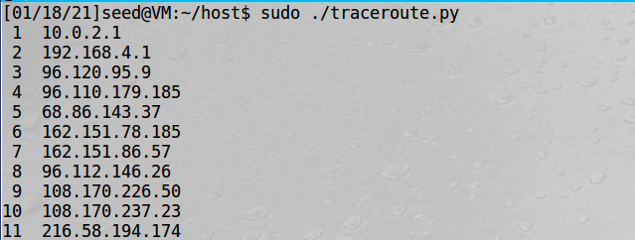

Observation: It takes 11 hops to get from our VM to [www.google.com](http://www.google.com) at ip address 216.58.194.174. We can see exactly how our request was routed.

Explanation: Scapy can be used to easily view the route a request takes by setting the appropriate parameters and looping through calling the sr1 function. The sr1 function is part of the send and receive packets function (sr) and only returns the packet that answered.

*1.4 Sniffing and-then Spoofing:*

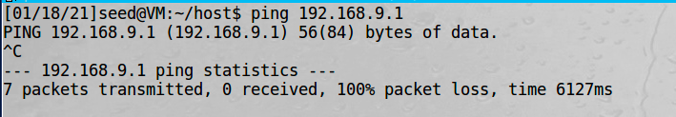

We pint 192.168.9.1 which is an ip we do not expect to respond. This is shown above by 100% packet loss.

Then we start our sniffing and spoofing program and ping the same address.

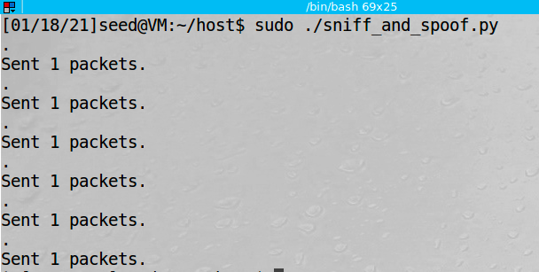

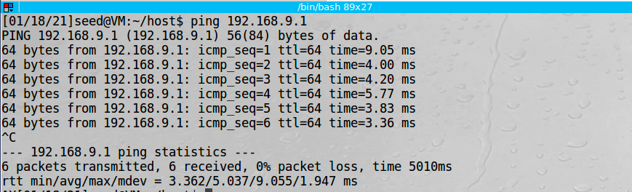

Observation: We now get echo reply’s from pinging the ip address 192.168.9.1 which we had previously shown would not reply. The is a result of our sniffing and spoofing program running on our second VM.

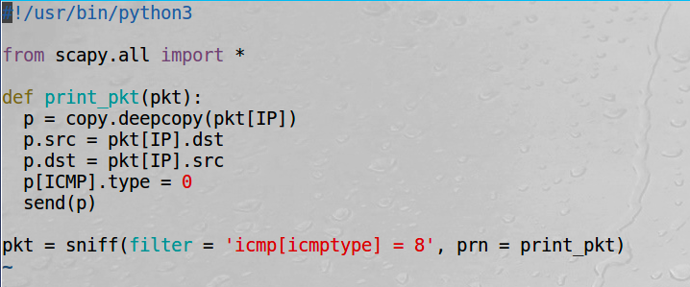

Explanation: The code above is sniffing for icmp packets. When it see one transmitted, it spoofs the reply by making a copy of the packet setting the source to the destination and the destination to the source and then sending it back. This impersonates the destination ip address and spoofs the reply. If we were an attacker, we could something more malicious like intercept other types of data and send back malicious responses.

**Task 2: Writing Programs to Sniff and Spoof Packets**

*2.1 Writing a Packet Sniffing Program:*

2.1A Understanding how a Sniffer Works:

The sniffer code written in c is shown below:

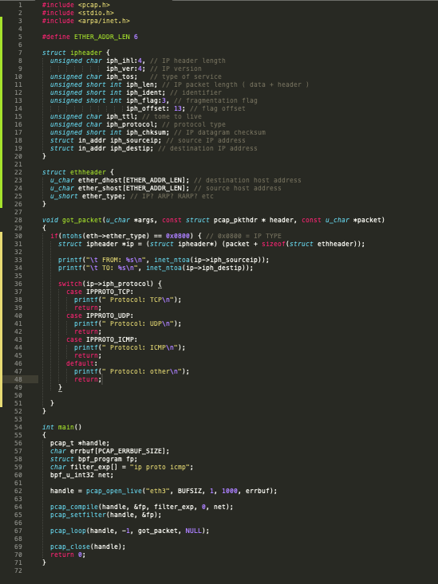

We create struct object to more easily manipulate the ip headers. This way we can simple move the memory pointer around and then access the different elements with an edge (->) and field name. When a packet is received the got_packet function will be invoked and the protocol, source IP address and destination IP address will be printed to the screen.

The following is output from the sniffer program while pinging google and opening a firefox browser:

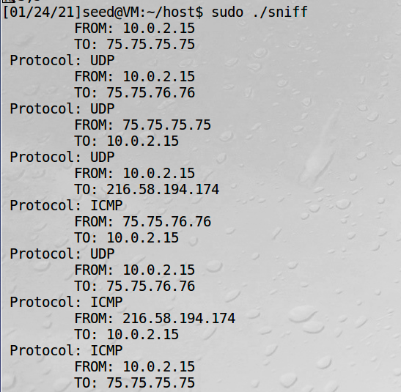

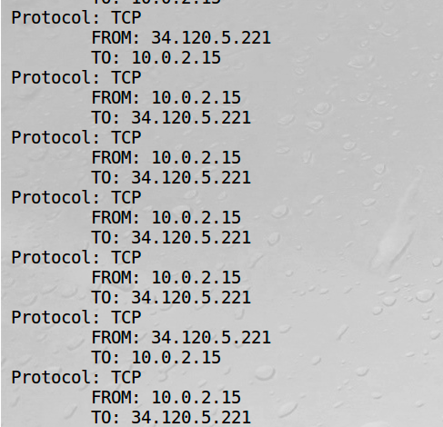

Observation: The images above show the traffic that is being sniffed from our sniff.c program that implements the pcap library. The program captures all packets, and we see examples of UDP, TCP, and ICMP packets being captured.

Explanation: The PCAP library can be used to create a raw socket and sniff network traffic. In our code we set the filter expression to “icmp ip proto” however we could change this to only detect specific types of packets if desired.

**Question 1:** The first thing that needs to occur is we need to open a live pcap session which creates a raw socket for us. We specify the network device we want to sniff and set the third parameter to 1 so place the NIC into promiscuous mode. Next, we need to set the filters by writing our filter expression and compiling them using pcap_compile. Once that is done, we can set them using the pcap_setfilter call. Finally, we capture packets by using pcap_loop. We can specify -1 in the second parameter to create and infinite loop and we also provide our call back function so that we can handle the packet and print out whatever necessary info we would like which is shown in our code example above.

**Question 2:** The pcap api internally initializes a raw socket. In order for the bind function to be allowed to proceed and promiscuous mode to be set, the program must be running with root privileges. If the program is attempted to run without root privilege a permission denied exception will be thrown when trying to call bind on the raw socket.

**Question 3:** We can turn promiscuous mode on and off by changing the third parameter in the pcap_open_live to 1 for promiscuous mode and 0 for normal mode. When we have promiscuous mode turned on, all network traffic will be sniffed even if the mac address does not match the computer the sniff program is being run on. This is shown in our screen shots above when we ping google.com or open firefox and the packets are captured. If we set the flag to 0 and run the program in normal mode, we will only be able to see packets sent to the machine’s mac address where the sniffing program is running. We can demonstrate this by setting the third parameter to 0 and then pinging google.com. We will not see any packets capture. Then if we ping 10.0.2.4 (the machines IP) we will see the ICMP packets captured. See screenshots below.

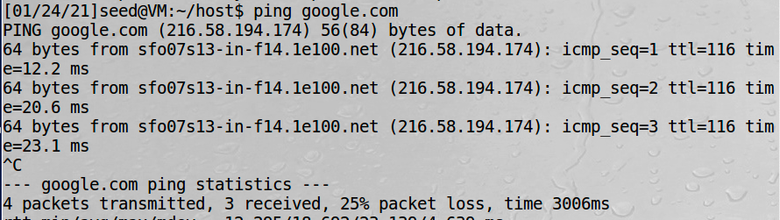

Ping google.com

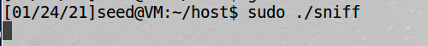

No packets capture.

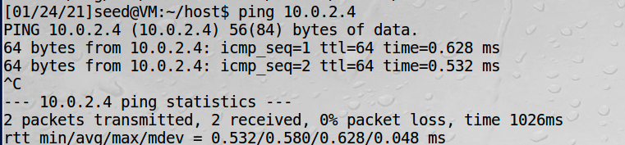

Ping the machines IP address running the sniffer program with the NIC in normal mode.

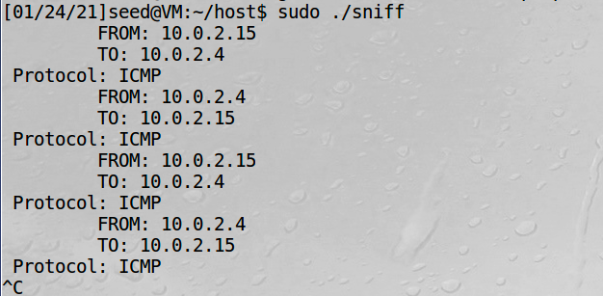

We cee the ICMP packets captured.

2.1B Writing Filters:

Different filters can be written to control which packets are sniffed. These filters are written in BPF syntax and compiled and set to the socket that is created with the pcap functions.

The following expression captures ICMP packets from source 10.0.2.15 and destination 10.0.2.4.



The following expression capture TCP packets with destination port in the range of 10-100:



2.1C Sniffing Passwords:

Packet sniffing can be used to steal passwords if they are transmitted in clear text. This is demonstrated below by sniffing telnet traffic and intercepting a users password:

First, we set our filter expression to the following:



Next, we need to modify our got_packet function to handle detecting the data. This is done in the screenshot below:

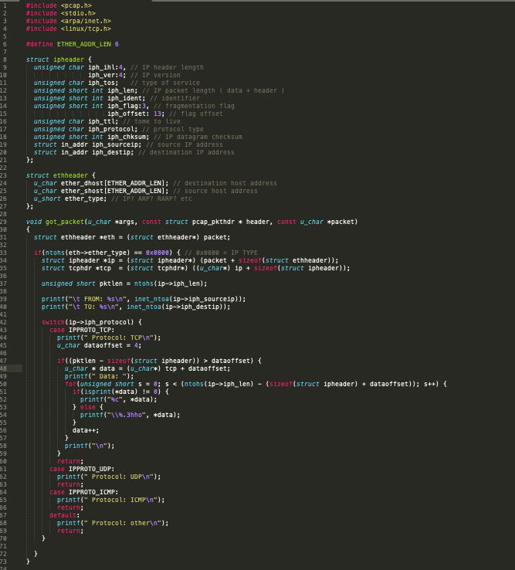

Example of password dees for seed user on vm 10.0.2.4:

First we run telnet 10.0.2.4 from other VM to login to remote VM:

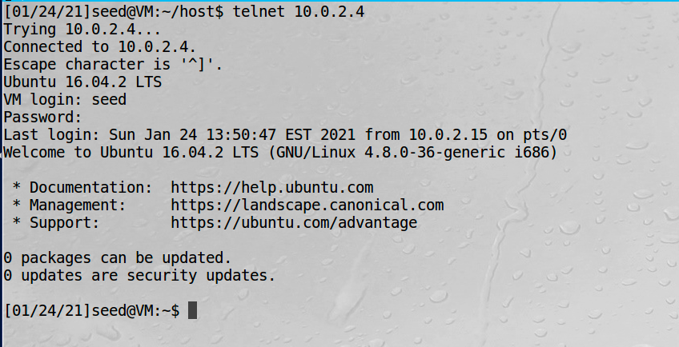

Then we can sniff the password from the other VM running the sniffer tool:

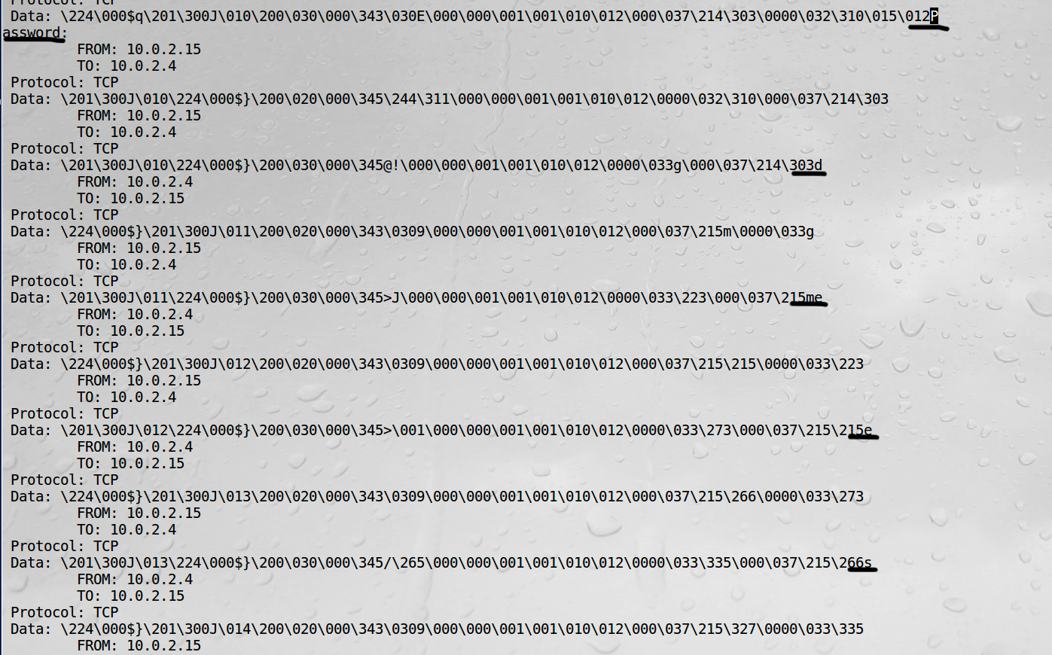

Observation: In the above screenshots we can see the sniffed password dees coming after the password prompt. These are underlined in the last screenshot above. The capture filter was used to capture telnet traffic and the data was sent from 10.0.2.4 to 10.0.2.15 and intercepted using our sniff program.

Explanation: By using the pcap library and filtering for telnet traffic we were able to capture the packets. When we captured the packets and printed them to the screen we were able to see the user password. This is why sensitive data should never be transmitted in clear text and we were able to show a practical use for a sniffing program.